AI WeatherWise - Deliver intelligent weather forecasts and insights
Description:
AI WeatherWise is a smart RESTful backend application developed using Node.js and Express.js. It uses MongoDB with Mongoose ODM to store and manage user and location-related data. The system provides real-time weather information and integrates Google Gemini AI to generate easy-to-understand weather summaries and useful recommendations based on current weather conditions.
The application includes secure JWT-based authentication, bcrypt password encryption, and APIs for adding, viewing, updating, and deleting favorite locations. It also supports a fallback mechanism when external API credentials are unavailable. Centralized error handling and request validation help maintain reliable and secure API operations.

Scenario-Based Case Study:
Background:
Alex is a frequent traveler who visits different cities for personal and recreational purposes. He wants a simple platform where he can check weather conditions, save his favorite locations, and receive useful AI-based suggestions before planning his activities
Problem:
● Difficulty in keeping track of weather conditions across several cities.
● No personalized suggestions for suitable outdoor activities or clothing.
● Raw weather values can be difficult to understand quickly.
● Need for a secure platform to save and access favorite locations from different devices.
Solution:
The AI WeatherWise system provides a centralized backend for collecting weather information and generating intelligent insights. It maintains secure user and location records in MongoDB and uses Google Gemini AI to convert weather data into simple summaries, recommendations, and activity suggestion
Usage:
● User Usage: Users can register securely, manage favorite cities, view current weather conditions, and request AI-generated summaries and recommendations.
● Developer/Admin Usage: Developers or administrators can check API availability, monitor registered users, and verify the connection between weather and AI services.
● Weather Application User: Users can access available weather information through public weather endpoints without necessarily creating an account.

Outcome:
By combining real-time weather information with AI-based analysis, AI WeatherWise makes weather data easier to understand and use. The system provides personalized recommendations while maintaining secure user data through authentication, validation, and Mongoose-based database management.

1. Software Requirements:
● Operating System: Windows 10/11, macOS, or Linux for cross-platform development and execution.
● Node.js (v16 or above): Provides the runtime environment required to execute the backend server and AI services.
● npm (v8 or above): Used for installing, updating, and managing the required Node.js packages.
● Gemini AI SDK: Uses "@google/generative-ai" to generate intelligent weather explanations and recommendations.
● MongoDB: NoSQL database used to store user information, favorite locations, authentication details, and application data.
● Postman: Used to test REST API endpoints, request methods, authentication, and server responses.
● Code Editor: Visual Studio Code or another suitable IDE for developing and maintaining the project.

2. Hardware Requirements:
● Processor: Intel Core i5 (8th Generation or above) / AMD Ryzen 5 or equivalent.
● RAM: Minimum 8 GB; 16 GB is recommended for smoother development with MongoDB and backend services running simultaneously.
● Storage: At least 1 GB of free storage space for the project files, dependencies, database-related files, and development tools.

Epic 1: PROJECT ARCHITECTURE:
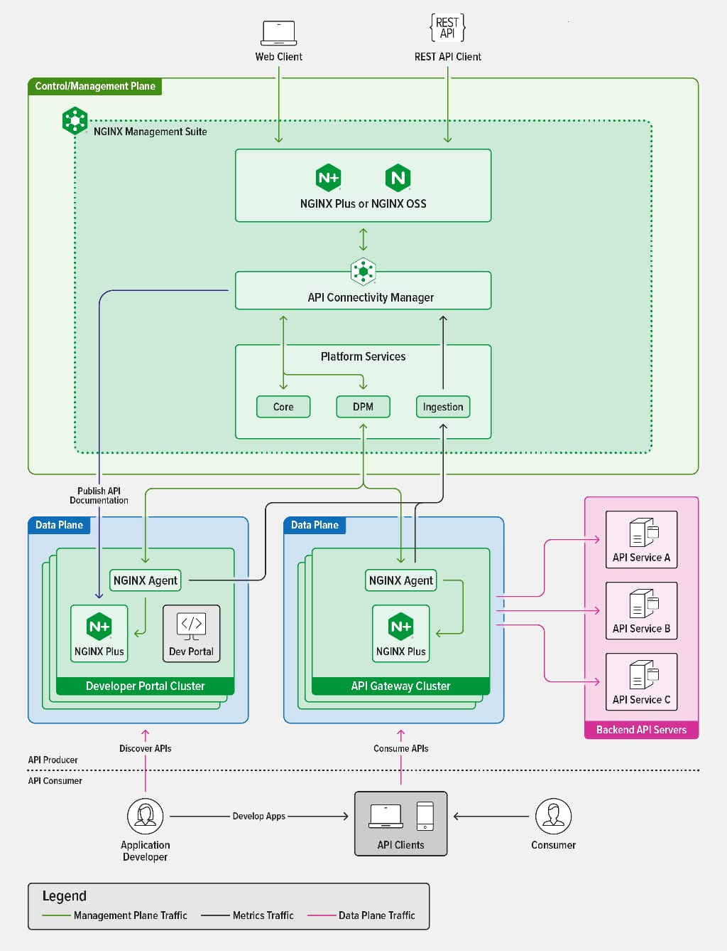

Components Definition:
● Interface: Tools such as Postman are used to send API requests through different endpoint paths and receive the required weather and user-related data in JSON format.
● Express Server Gateway: Acts as the main entry point of the application. It listens for client requests, manages HTTP methods such as GET, POST, PUT, and DELETE, processes JSON data, and manages CORS configuration.
● Authentication & Role Matrix Middleware: Reads authentication tokens from request headers, verifies the user's identity using JWT, and checks whether the user has the required permission to access protected API resources.
● Granular Services (Logic Modules): Contains separate application logic for handling weather operations, user management, favorite locations, AI insights, and other system-level functions in an organized manner.
● Database Interface Layer: Mongoose provides communication between the application and MongoDB by converting application operations into database queries and managing structured data through schemas and models.
● AI Service Integration: Uses the "@google/generative-ai" package to communicate with Google Gemini AI and produce understandable weather summaries, activity suggestions, and personalized recommendations using current weather information.
Entity-Relationship (ER) Diagram Description: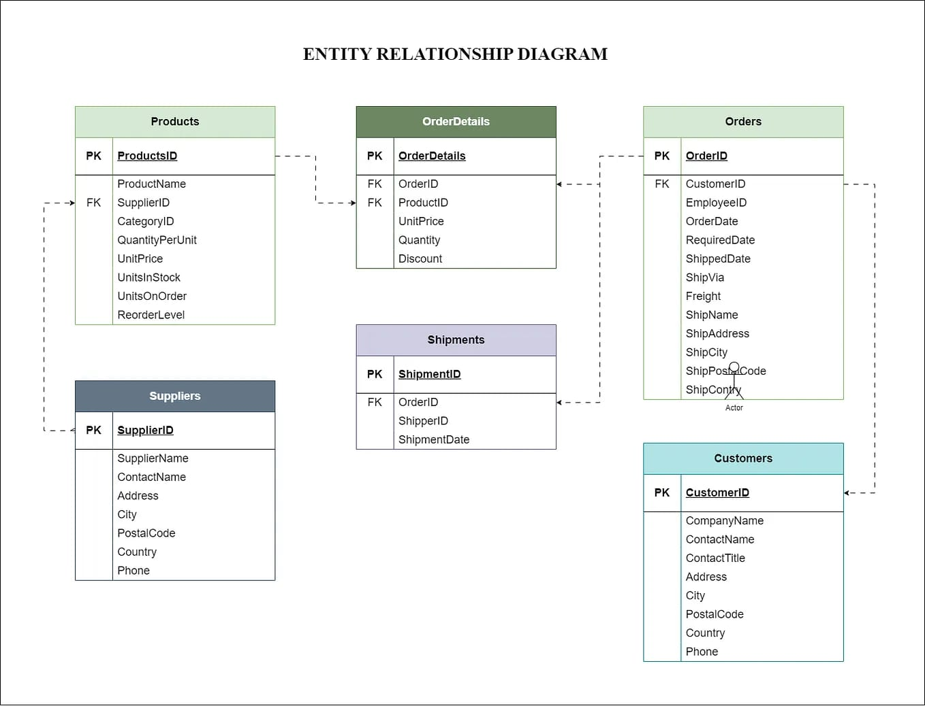
The data architecture manages User profiles and their associated favorite Locations through logical references:
1. User Entity:
● _id (Primary Key - ObjectId)
● name (String, Required)
● email (String, Required, Unique)
● password (String, Encrypted/Hashed, Required)
● role (String, Default: "reader")

2. Location Entity:
● _id (Primary Key - ObjectId)
● user (Reference Key linked to User Collection)
● city (String, Required)
● country (String, Required)
● createdAt (Date, Default: Current Date/Time)

Key Structural Mappings:
● User to Location (One-to-Many): One registered user can associate and maintain several favorite weather locations within the system.

Key Features:
● Role-Based Route Protection: JWT authentication and authorization checks ensure that only permitted users can access restricted API operations.
● Favorite Location Management: Users can add, view, update, and remove their preferred cities through dedicated CRUD operations.
● Real-Time Weather Retrieval: The system obtains current weather details such as temperature, humidity, wind speed, and other environmental conditions.
● AI Weather Insight Generation: Gemini AI processes available weather information and produces easy-to-understand summaries and useful recommendations.
● Input Validation & Security: Request validation and data sanitization help prevent invalid inputs, unauthorized access, and common security-related issues

Roles and Responsibilities:
● Admin:
○ Manages registered user accounts and supervises user-related operations.
○ Checks server availability and monitors important application activities.
○ Oversees database records and helps maintain the overall reliability of the system.

● Registered User:
○ Adds and manages personal favorite weather locations.
○ Requests current weather information for selected cities.
○ Uses Gemini AI to receive weather explanations and activity suggestions.
○ Maintains their account information and authentication details securely.

User Flow:
1. User Registration/Login: The user creates an account or signs in using valid credentials.
2. Save Location: The user adds a preferred city to their favorite locations through the API.
3. Get Weather Data: The system retrieves the latest weather information for the selected location.
4. Generate AI Insights: The user requests an AI-generated summary or recommendation based on the current weather.
5. Authentication & Response: The server verifies the JWT token, processes the request, and sends the required information back to the user.
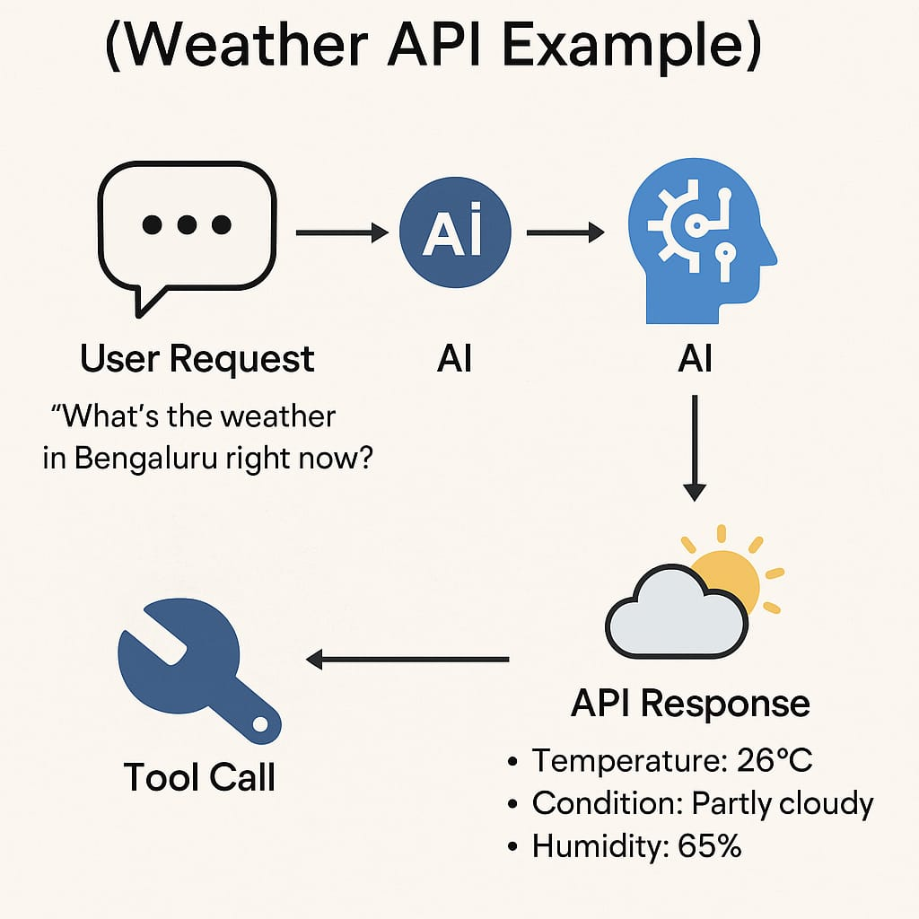
MVC Architecture Pattern:
The system architecture structures its source configuration layers around the Model-View-Controller design pattern to completely decouple components:

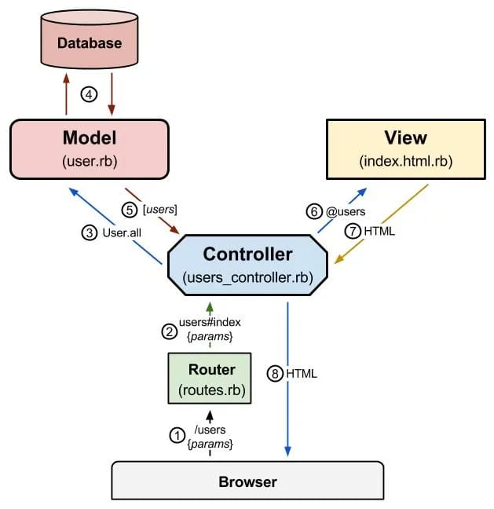
Model Layer (Data Blueprint):
The Model Layer defines the application's data structure using Mongoose schemas. It specifies required fields, data types, default values, relationships, and validation rules before storing information in MongoDB. This layer ensures that user and location data are organized and consistently maintained within the database.

Controller Layer (Execution Matrix):
The Controller Layer manages the main application logic between API requests and database operations. It receives requests from the routing layer, validates the required information, performs the appropriate processing, communicates with the models or external services, and sends the processed results back to the client in JSON format.

View Layer (Routing Network Interface):
Since AI WeatherWise is a headless RESTful backend application, it does not contain traditional web pages or UI templates. Instead, the API Routing Layer acts as the interface between clients and controllers. It maps HTTP requests and endpoint paths to the appropriate controller functions and returns the required API responses.

Epic 2: Project Setup and Configuration:

Creating the Project Folder:
- Create a new folder named AI Weatherwise
- Open the project folder in Visual Studio Code.
- Initialize the project using Node.js and install the required dependencies.

Project Initialization:
Open the project folder in the VS Code terminal and execute:
npm init -y
Install the required dependencies:
npm install express mongoose bcryptjs jsonwebtoken cors dotenv multer @google/genai
Install Nodemon for development:
npm install --save-dev nodemon

Create the Following Files:
- .env
- package.json
- .gitignore

Create the Following Folder Structure:


Environment Configuration:
A ".env" configuration file should be created in the root directory of the project to securely store the application's environment-specific settings and sensitive credentials.

PORT=5000
MONGO_URI=your_mongodb_connection_string
JWT_SECRET=your_jwt_secret
GEMINI_API_KEY=your_gemini_api_key
These variables allow the application to configure the server port, establish a connection with MongoDB, secure JWT authentication, and communicate with the Google Gemini AI service.

Epic 3: Backend Development:
The AI WeatherWise backend is implemented using Node.js, Express.js, and MongoDB with a modular and organized architecture. Different responsibilities are separated into routes, controllers, middleware, models, and utility components, making the application easier to maintain, test, and extend.
The backend provides secure RESTful APIs for user authentication, favorite location management, real-time weather retrieval, AI-based weather insights, and administrative functions. This structured approach supports reliable API communication and future scalability of the application.
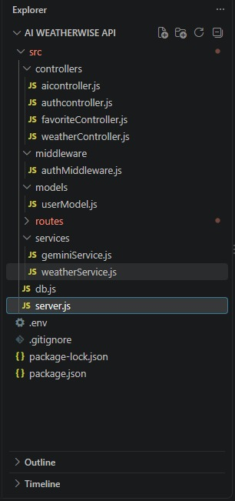
Epic 4: Database Configuration:
API Testing Demo:
1. Configure MongoDB:
● Install Mongoose:
Add the Mongoose package to the Node.js project by executing the following command in the project directory:
npm install mongoose
● Establish Database Connection:
Configure the backend application to connect with the MongoDB database using the MongoDB connection URL.
● Define Schemas & Models:
Create Mongoose schemas and models to specify the structure, data types, and validation rules for the application's database collections.
Create Database Connection:
Before performing database-related operations, the backend must establish a successful connection with MongoDB. The Mongoose connection is initialized when the application starts, allowing the API to safely perform operations such as creating, retrieving, updating, and deleting records.
The database connection code can be implemented using the MongoDB connection string stored in the environment configuration.
Mongoose Schema Definitions:
Mongoose schemas define how application data is structured and stored inside MongoDB. They specify the required fields, data types, default values, and validation rules for each collection.
Location Schema:
The Location Schema defines the structure used to store a user's favorite weather locations. It contains details such as the associated user, city, country, and creation date, allowing the system to maintain and retrieve saved locations efficiently.

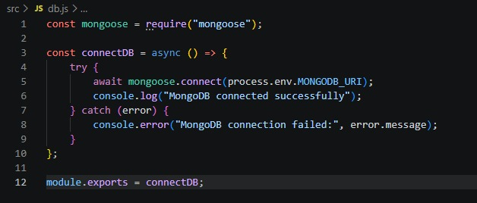
User Schema:
The User Schema defines the structure of user account information stored in the MongoDB database. It contains the user's name, email, password, and role. The email is kept unique to avoid duplicate accounts, while the password is stored in hashed form for security. The role field helps manage user access within the application.
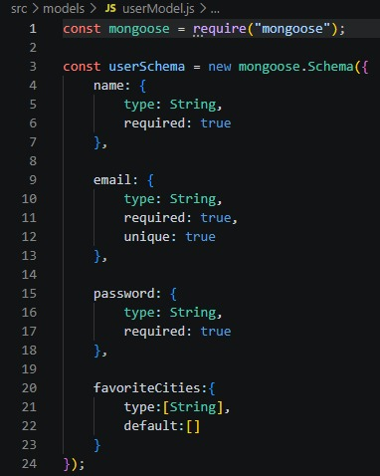
Db connection:
This module establishes a connection between the application and MongoDB using Mongoose. It ensures that the backend communicates with the database before processing any client requests.
Epic 5: Project Execution:
The AI WeatherWise backend application can be run on a local system using the Node.js environment. Before starting the project, make sure that the MongoDB service is active and all necessary environment variables are properly configured. The RESTful API endpoints can be accessed and tested using tools such as Postman or Thunder Client.

Running the Backend Server:
Install the project dependencies:
npm install
Launch the application server:
npm start
Once the application starts successfully, it establishes a connection with MongoDB and runs the Express server on the configured port. The backend is then ready to receive and process API requests from Postman, Thunder Client, or other client applications.

API Testing:
Register API:
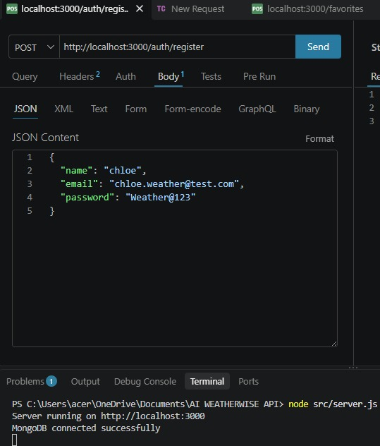
Login API:
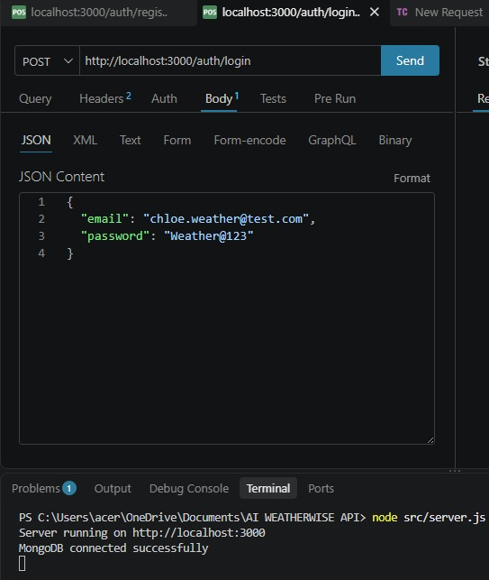
Weather Summary:
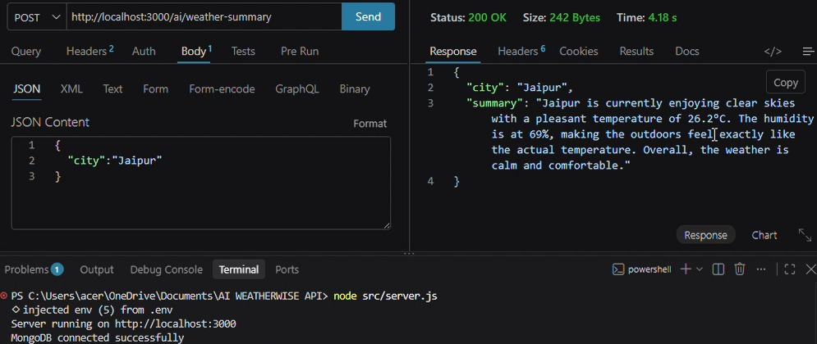
Weather Recommendation:
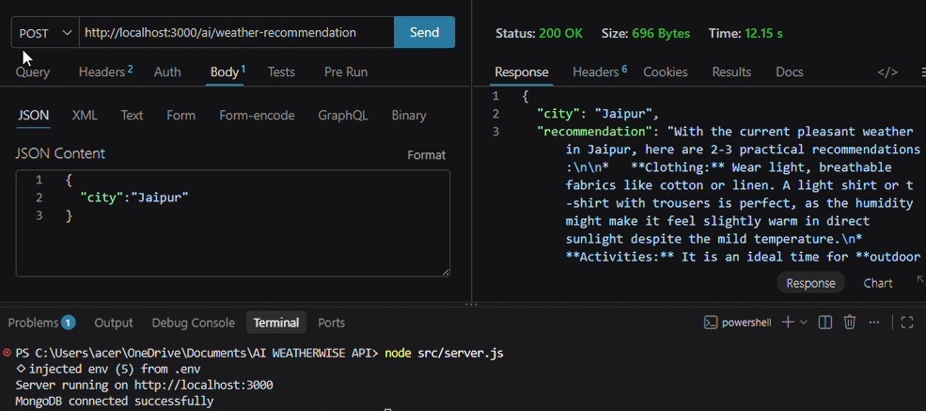

API and Demo Video Link: https://drive.google.com/file/d/1XRQp9CXqn2KLh-lnZtnSTnMTFdOyr3yy/view?usp=drivesdk
CodeDrive: https://drive.google.com/drive/folders/1PQBWSNtBhNvko0EKD2QpH77vGN2-a3jO?usp=sharing

